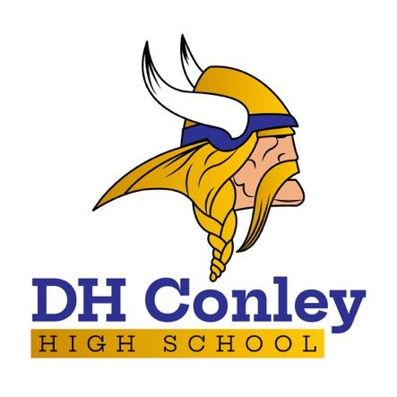
Regular Bell Schedule

2023-24

Entry Bell | 8:20
1st Period | 8:30 – 10:04
2nd Period | 10:09 – 11:43
3rd Period | 11:48 – 1:50
1st Lunch | 11:48 – 12:12
2nd Lunch | 12:20 – 12:44
3rd Lunch | 12:53 – 1:17
4th Lunch | 1:26 – 1:50
4th Period | 1:55 – 3:30

DH Conley Mission Statement:
D. H. Conley High School will strive to provide a safe, diverse and challenging learning environment that graduates skilled life-long learners who are college/career ready and can positively impact our global society.

DH Conley Mission Vision Statement:
D. H. Conley High School will partner with all students and stakeholders to provide a safe, individualized learning environment that utilizes twenty-first century skills so our students are college/career ready and are productive in the global community.

